DAG Examples
1) a = b x c
d = b
e = d x c
b = e
f = b + c
g = f + d

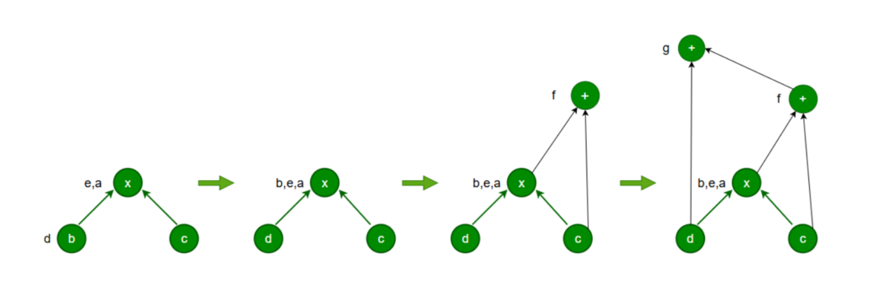
2) T1:= 4*Io
T2:= a[T1]
T3:= 4*Io
T4:= b[T3]
T5:= T2 * T4
T6:= prod + T5
prod:= T6
T7:= Io + 1
Io:= T7
if Io <= 20 goto 1
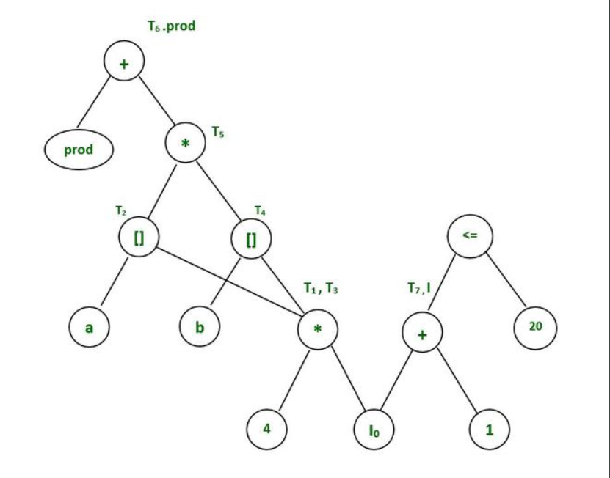

3) T1 = a + b
T2 = a – b
T3 = T2 * T1
T4 = T1 – T3
T5 = T4 + T3
